Unit 2: Activities 2.4 Worksheet
1. There are several theories about how and when the first humans came to North and South America. The Beringia theory was briefly described on page 16. There are three other theories some use to explain how humanity arrived in North America: the intercontinental sea travel theory, the American Dawn theory, and the American Genesis theory.
- Divide the class into four groups. Using a combination of your local library and Google each group is responsible for investigating one of the four theories listed above, e.g. Beringia, intercontinental sea, American Dawn, and American Genesis.
- Each group is responsible for presenting the following to the class in the form of a digital presentation: a description of the theory and supporting evidence for the theory.
- The presentation should have the following slides: a title slide (include the name of your theory of study and a relevant picture); a description slide (describing the theory); and two to four supporting evidence slides (each slide introducing supporting evidence and images); and a concluding slide (where the group concludes/explains whether or not the theory is valid).
- Each member of the group must speak during the presentation which should be no shorter than two minutes in length; all slides should be free of grammatical and technical errors; also, include the URL of websites used to gather information appearing on each slide; the presentation will be assessed on the rubric below.
Category/Performance | 3 | 2 | 1
Critical Thinking  Have we accurately assessed the value and reliability of the sources we utilized? | Group thoughtfully and accurately interprets topic while using effective sources.  Presentation shows in-depth understanding of major ideas. | Group identified relevant arguments but one of the sources used is problematic.  Presentation presents basic understanding of major ideas. | Group struggled to focus the presentation’s purpose adequately.  Presentation is rudimentary and basic lacking insight.
Quality of Information  Have we covered the topic adequately by presenting the necessary supporting ideas? | Group covers topic thoroughly.  Presentation includes sufficient evidence in support of the topic. | Group covers essential information.  Presentation includes some supporting details. | Group incorporates the minimum essential information.  In terms of the presentation, details are somewhat lacking.
Organization  Is the presentation logically organized and does it conclude effectively? | Presentation is well-organized and coherent.  Topics are presented in logical sequence, including clear introduction and conclusion. | Presentation is generally well-organized.  Some attempt made at organization and conclusion relatively clear. | Some attempt at organization.  Conclusions are weak and not supported by the available evidence.
Grammar & Spelling  Is the presentation entirely free of grammatical and spelling errors? | All grammar and spelling are correct. | One or two errors detected. | More than two errors identified.
Teamwork  How well did the group members work with one another? | Team is ready to present by deadline.  Group made consistent effective use of work periods. |  | Team is not ready to present by deadline.  Group did not make consistent effective use of work periods.

- Immediately following the final group presentation, discuss as a whole class the theory most supported by both logic and the available evidence. Write down a detailed explanation of the consensus answer reached by the class in the space below.

2. In the space below, provide a definition for concept of a central government. What evidence is there to support the view that the Olmec had a strong central government? If you use a web resource to find the above definition or answer the question following, cite the sites using Chicago style. Format your citation using the the Citation Machine (http://www.citationmachine.net/).
Central Government Definition:

Definition Citation:
What evidence is there supporting the view that the Olmec had a strong central government?

Answer Citation:
3. Ask your teacher for a blank outline map of North, Central and South America. Use a combination of the Internet and this reading to show—using both dates and arrows indicating the direction knowledge of agriculture spread throughout the Western hemisphere.
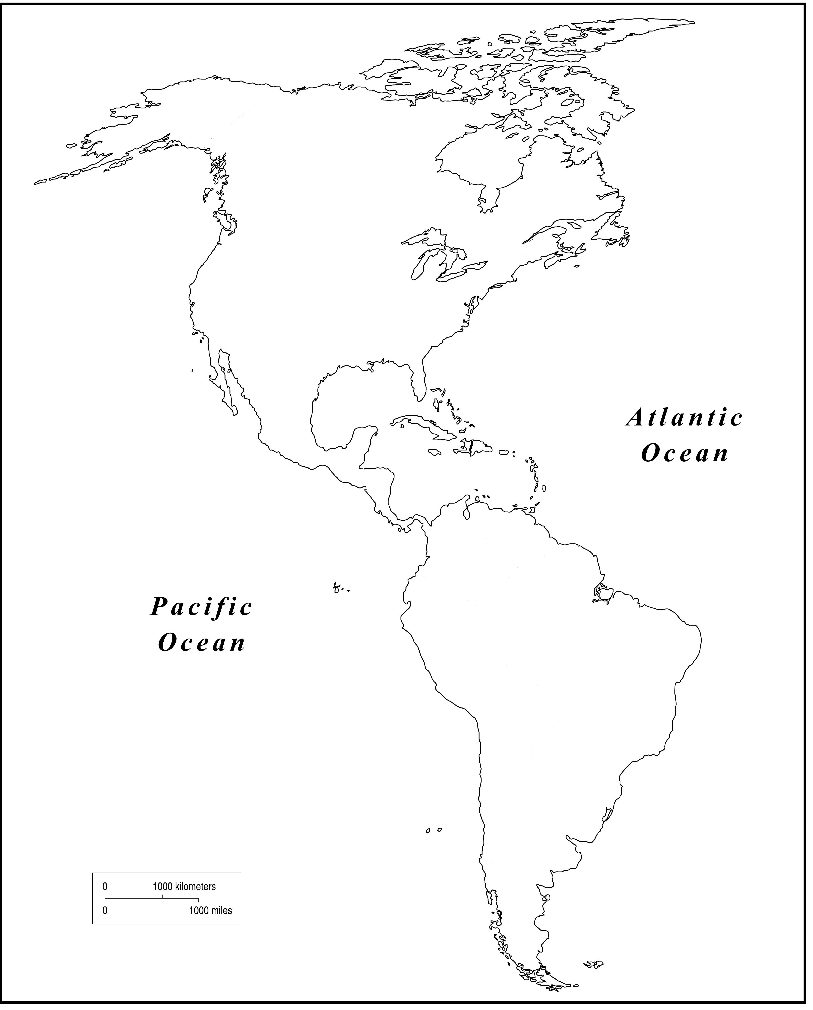
4. In small groups, discuss the role geography plays in the appearance and development of civilizations. Be sure to answer the following focus questions:
- In terms of geographic location, what do the various civilizations discussed in this unit share in common with one another?

- For what specific reason was Mexico a particularly good place to start a civilization?

- Why would Saskatchewan be an unlikely place for an early civilization like Sumer to begin?

5. Jigsaw Activity
a). Form into expert groups of four. As a group select one of the following civilizations to study: Egypt, Minoa, Maya, Aztec, Inca, and the Iroquois. In your expert groups, conduct research and record your answers to the following focus questions:
- Where and when did your civilization exist?
- What type of government did it have?
- What were the main spiritual beliefs, customs and practices?
- What types of technology did your civilization invent and/or use?
- What were the main types of jobs and occupations men and women worked?
- What roles did children, men and women have?
- What methods of recording and communicating information did your topic civilization use?
Note: be sure to keep track of the URLs and/or print sources you use to draw your research from.
b). Use the chart below to organize your information. Meet in your expert groups to discuss your findings.
c). Form into blended groups—one person per civilization—and share your research teaching one another about each civilization. Use the chart below to complete the information gathering task.
d). After completing the task described above fill out the small group rubric under the chart. This rubric measures your personal performance for the small group work completed.
Questions/Civilization
Where and when did your civilization exist?

What type of government did it have?

What were the main spiritual beliefs, customs and practices?

What types of technology did your civilization invent and/or use?

What were the main types of jobs and occupations men and women worked?
What roles did children, men and women have?

What methods of recording and communicating information did your topic civilization use?

Category/Performance |  | 3 |  | 2 |  | 1
Quality of Focus  Focus is defined as your capacity to follow directions (written and/or oral), complete tasks, meet deadlines, and remain on-task. |  | I followed all directions completing tasks as required and outlined by deadline.  I remained on-task for the entire duration of the group activity. |  | I struggled at times with directions but completed all tasks as required and outlined by deadline.  I remained on-task for most of the group activity. |  | I struggled at times with directions and I did not complete all tasks as required and outlined by deadline.  I was off-task for a good proportion of the group activity.
 |  | 3 |  | 2 |  | 1
Quality of Participation  Participation is defined as your capacity to contribute meaningfully to the success of the group through active listening, asking questions, and sharing your own opinions and insights. |  | I contributed meaningfully to the group’s success by listening actively, e.g. listening to understand and potentially ask a clarifying question.  I asked two or more questions while also sharing my own opinions and answers. |  | I contributed meaningfully to the group’s success by mostly listening actively, e.g. listening to understand and potentially ask a clarifying question.  I asked one question while also sharing my own opinions and answers. |  | I did not listen actively, e.g. I didn’t always listen to understand or to create a clarifying question.  I did not ask any questions or share any of my own opinions or answers.

6. If you had the opportunity to travel back in time and visit one of the civilizations presented in this unit, which one would go to? Use the space below to explain your reasoning.

